

School of Computer Science Engineering and Information Systems

Fall Semester 2026-2027

BCSE303P

Operating Systems Lab

Project Review -1
Agentic AI Control Layer for Linux

Sarthak Trivedi - 24BYB0192
Mrinal Gupta - 24BDE0027
Vaaman Bansal - 24BDE0067
Under the Guidance of
Dr. PORKODI S
Assistant Professor Senior Grade – 1
School of Computer Science Engineering and Information Systems

ABSTRACT:
Modern operating systems still require users to interact manually with files, processes, and applications, while existing AI assistants are largely limited to suggesting commands rather than executing them. This project proposes an agentic AI control layer for Linux that closes this gap by letting a large language model plan and execute real operating-system actions on a user's request. A fast inference engine served by Groq interprets natural-language commands and decides the next action, while a capability-based broker validates every action against an explicit policy before it reaches the operating system, logging each decision for accountability. Approved actions are carried out through a defined set of tools that wrap standard Linux system calls, covering file operations, process management, and subprocess execution. Unlike unrestricted AI-agent tools that grant broad system access, this design enforces the principle of least privilege, drawing directly on classical protection mechanisms such as access matrices and capability-based systems. The project is implemented in phases, beginning with read-only inspection tools and progressively introducing write access, process control, and a confirmation step for destructive operations, demonstrating core operating-system concepts through a practical, working prototype.
Keywords: Operating Systems, Agentic AI, Capability-Based Security, System Calls, Process Management, Large Language Models

INTRODUCTION:
Operating systems form the foundation on which every user action, opening a file, running a program, or monitoring a process, ultimately executes. Traditionally, automating tasks across an operating system has required either manual intervention or scripting expertise, limiting accessibility for non-technical users. In recent years, large language models (LLMs) have shown strong ability to interpret natural language and plan multi-step actions, motivating a new class of software known as agentic AI: systems that not only converse but also act on behalf of a user. Anthropic's Claude with computer use and open-source projects such as Open Interpreter demonstrate that LLMs can already drive real applications, but most such systems grant broad, largely unstructured access to the underlying machine. This project explores how core operating system concepts, specifically system calls, process management, and capability-based protection, can be used to build a safer version of this idea: an agentic layer for Linux where every AI-initiated action is checked against an explicit permission model before it is allowed to execute.
PROBLEM STATEMENT:
Despite rapid progress in conversational AI, there is no widely available system that lets an AI agent safely and directly control a user's operating system. Existing options fall into two extremes: conversational assistants that can only suggest commands, leaving the user to copy, verify, and execute them manually; or automation tools and emerging AI agents that can execute commands but typically do so with broad, unchecked system access and little enforced permission model. Consequently, users must choose between safety and convenience, and no mainstream solution places operating-system-level protection mechanisms, such as capability-based access control, at the centre of AI-driven automation.
OBJECTIVES:
1. To design and implement an agentic layer that translates natural-language requests into concrete actions on a Linux system, using an LLM served by Groq.
2. To enforce a capability-based permission model so that the AI agent can perform only explicitly authorised operations.
3. To implement a defined set of tool wrappers around Linux system calls for file operations, process management, and subprocess execution.
4. To apply core operating system concepts studied in this course, including process control blocks, system calls, scheduling, and protection mechanisms, within a practical, working system.
5. To evaluate the prototype through a phased implementation, from read-only inspection to permissioned write and process-control operations.
SCOPE OF THE PROJECT:
This project is scoped as a semester-level prototype rather than a production system. It targets a single-user Linux environment and a fixed, explicitly declared set of tools rather than unrestricted shell access. The prototype covers file inspection and modification within a sandboxed workspace, process listing and management, and a basic request-plan-execute loop; it does not extend to full desktop or GUI automation, multi-user policy management, or cross-platform support at this review stage. Any networking actions are restricted to read-only lookups. The security model is limited to a rule-based capability broker; adaptive or learning-based policy refinement is identified as future work rather than part of the current scope.
PROPOSED SYSTEM:
The proposed system replaces the conventional request-and-suggest pattern of chat-based assistants with a closed request-plan-check-execute loop. The user issues a natural-language instruction, which a Groq-hosted LLM interprets and translates into one call from a fixed, explicitly declared set of tool functions rather than an arbitrary shell command. Before any such call reaches the operating system, a capability broker checks it against a policy file that states exactly which paths, processes, and operations the agent is authorised to touch, drawing directly on the access-matrix and capability-based protection models studied in this course. Only approved calls are dispatched to an OS-interface layer of tool wrappers that invoke the underlying Linux system calls for file access, process inspection and control, and subprocess execution; every decision, approved or denied, is written to an audit log. The result of the executed action, an exit code, updated file state, or process status, is fed back to the LLM so that it can plan its next step, which is what makes the system agentic rather than a single command-and-response tool. Destructive operations, such as deleting a file or terminating a process, additionally require an explicit confirmation step from the user before the broker will execute them. The system is built incrementally in four phases: read-only inspection tools first, then permissioned file writes and command execution, then process management, and finally a confirmation layer for destructive actions, so that a working, demonstrable prototype exists at every stage of the semester.
SYSTEM ARCHITECTURE:
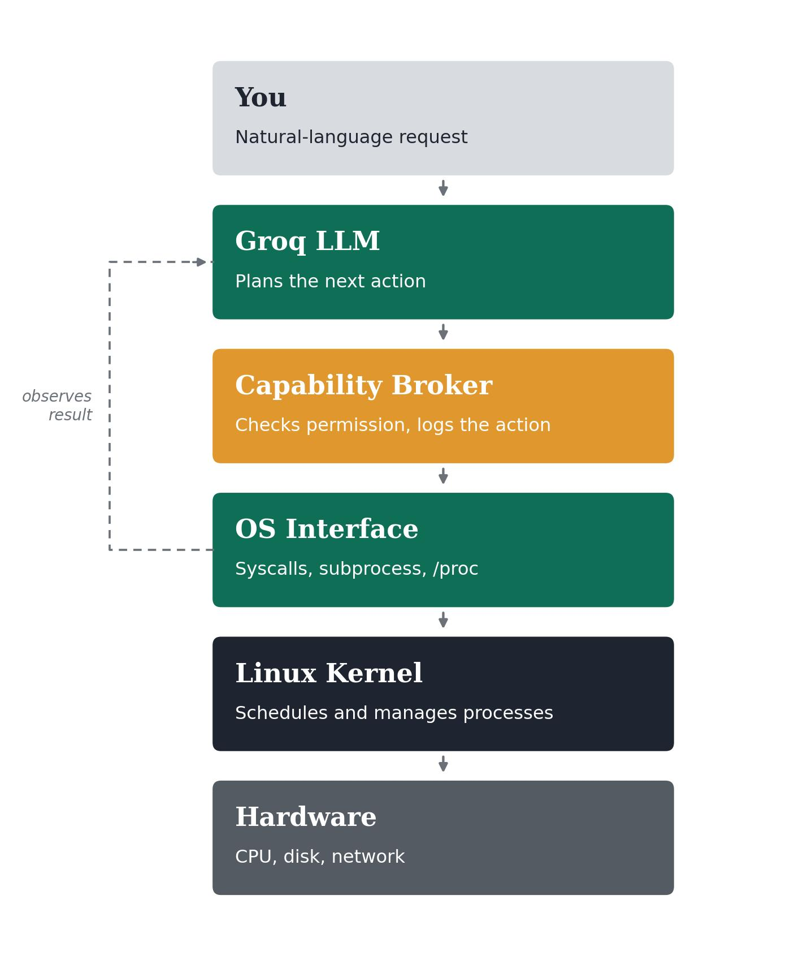
Fig. 1. Layered architecture of the agentic control layer, showing the request-plan-check-execute loop.

As shown in Fig. 1, the request from the user is first handed to the Groq-hosted LLM, which plans the next action. Every planned action then passes through the capability broker, shown in amber because it is the security-critical layer: it checks the requested action against an explicit policy and logs the decision before anything is allowed to proceed. Only approved actions reach the OS-interface layer, which wraps the standard Linux system calls, subprocess execution, and /proc-based process inspection needed to carry the action out; the Linux kernel and hardware beneath it are not modified in any way. The dashed feedback path is what distinguishes this design from a single fire-and-forget command: the result observed at the OS-interface layer, an exit code, a file diff, or a process state, is returned to the LLM so it can decide its next action, closing the agent loop.
Table 1 maps each architectural component back to the operating-system concepts from the course syllabus that it is intended to demonstrate.
Project component | OS module it demonstrates
Capability broker and policy checks | Module 7 – access matrix, capability-based systems, policy vs. mechanism
Tool interface (read_file, write_file, run_command) | Module 2 – system calls, user/kernel mode boundary
Process spawning and monitoring for agent actions | Module 2/3 – fork/exec/wait, process control block, process states
Audit log and confirmation step before destructive actions | Module 6/7 – journaling concept, protection mechanisms
Sandboxed execution workspace | Module 6 – container virtualization

REFERENCES:
[1] A. Silberschatz, P. B. Galvin, and G. Gagne, Operating System Concepts, 10th ed. Hoboken, NJ, USA: Wiley, 2018.
[2] A. S. Tanenbaum, Modern Operating Systems, 4th ed. Harlow, UK: Pearson, 2016.
[3] W. Stallings, Operating Systems: Internals and Design Principles, 9th ed. Harlow, UK: Pearson, 2018.
[4] J. B. Dennis and E. C. Van Horn, "Programming semantics for multiprogrammed computations," Communications of the ACM, vol. 9, no. 3, pp. 143–155, Mar. 1966.
[5] B. W. Lampson, "Protection," ACM SIGOPS Operating Systems Review, vol. 8, no. 1, pp. 18–24, Jan. 1974.
[6] S. Yao, J. Zhao, D. Yu, N. Du, I. Shafran, K. Narasimhan, and Y. Cao, "ReAct: Synergizing reasoning and acting in language models," in Proc. 11th Int. Conf. on Learning Representations (ICLR), 2023.
[7] T. Schick, J. Dwivedi-Yu, R. Dessì, R. Raileanu, M. Lomeli, L. Zettlemoyer, N. Cancedda, and T. Scialom, "Toolformer: Language models can teach themselves to use tools," in Proc. 37th Conf. on Neural Information Processing Systems (NeurIPS), 2023.
[8] Anthropic, "Introducing computer use, a new Claude 3.5 Sonnet, and Claude 3.5 Haiku," Anthropic News, Oct. 22, 2024. [Online]. Available: https://www.anthropic.com/news/3-5-models-and-computer-use
[9] D. Merkel, "Docker: Lightweight Linux containers for consistent development and deployment," Linux Journal, vol. 2014, no. 239, Mar. 2014.
[10] Groq Inc., "Groq LPU Inference Engine: Technical Overview," Groq Documentation. [Online]. Available: https://groq.com

